SUPREME COURT OF THE STATE OF NEBRASKA
CERTIFICATE OF AUTHORITY

This registration certificate is hereby issued by the Nebraska Supreme Court to Exact Firm Name.
___________________________________________________________________ ________
(Exact Firm Name)
for the practice of law as a domestic professional organization in the form of a professional corporation with limited liability.
The Clerk of the Supreme Court of the State of Nebraska does hereby certify that the officer(s), director(s) and shareholder(s) of the above-named professional corporation, to wit:
Name, Residence, Address, City, State, ZIP.
_______________________ ____________________________________
(NAME, RESIDENCE ADDRESS, CITY, STATE, ZIP)

Name, Residence, Address, City, State, ZIP.
_______________________ ____________________________________
(NAME, RESIDENCE ADDRESS, CITY, STATE, ZIP)

Name, Residence, Address, City, State, ZIP.
_______________________ ____________________________________
(NAME, RESIDENCE ADDRESS, CITY, STATE, ZIP)

PLEASE ATTACH SEPARATE LIST IF NEEDED

is/are duly licensed to practice law in the State of Nebraska and that the above-named professional corporation with limited liability complies with the provisions of the Nebraska Professional Corporation Act and the canons, rules, and regulations imposed by the Nebraska Supreme Court for professional corporations with limited liability.
The address of the professional corporation at which the applicant proposes to perform professional services is

Address, City, State, ZIP.
_____________________________________________ .
(Address, City, State, Zip)

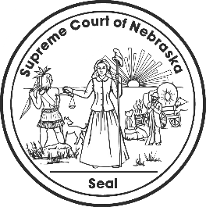
IN TESTIMONY WHEREOF, I have hereunto set my hand and caused to be affixed

the Seal of the Court, in the City of Lincoln, this __________________.

__________________________________________________
Clerk, Supreme Court of Nebraska

This certificate expires one year from the date of issuance.

